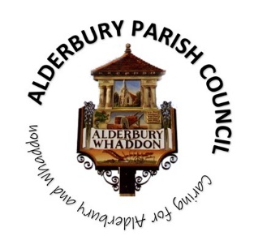
ALDERBURY PARISH COUNCIL
Caring for Alderbury and Whaddon

You are summoned to an ORDINARY MEETING of Alderbury Parish Council
to be held 7.30 on Thursday March 5th 2026
The Fountain Room at The Village Hall, Alderbury

Alderbury Parish Council has signed the Civility Pledge
Alderbury Parish Council has adopted a forward plan which will inform their decisions

7.30
15 minutes is set aside for the public to ask questions.
Please restrict comments and/or questions to three minutes. After question time, the public will only be able to speak if invited by the Chair.

AGENDA

- ACCEPT reports from 7.45
  - PC Kelvin Ramsey
  - Wiltshire Cllr Gregory Cooper

- ACCEPT Apologies for absence for the reasons given

- RECEIVE Declaration of Councillors’ Interests and Dispensations relating to matters on this agenda

- APPROVE the minutes of the meeting held on Feb 11th 2026

- NOTE the resignation of Alex Wilkinson
  - PROPOSAL to appoint a vice chair
  - CONSIDER other roles he held

- REVIEW the action log

- Planning 8pm
  - RESPOND to:
    - PL/2026/01173 Chuzzlewit, Silver Street – fell 6 ash trees
    - ACV/2026/00004 Allotments at Southampton Road
  - DISCUSS enforcement action at The 3 Crowns
  - PROPOSAL – to authorise John Fuller and the clerk to agree wording with Heritage Homes asking Wiltshire Council to vary the s.106 agreement for PL/2022/03103

- Matters of community interest 8.15
  - REVIEW the forward plan
  - UPDATE on arrangements for the annual parish meeting 28th April 2026
    - Agree agenda/focus for meeting
    - Review poster
    - Commit to door-to-door deliveries
  - CONSIDER communications from residents and agree any actions
  - DISCUSS the licence variation at The Green Dragon
  - RECEIVE a report from the footpath WG
    - CONSIDER any requests for support and authorisations needed

- Highways 8.30
PROPOSAL TO APPROVE the suggested road improvements around Light’s Lane and the contribution of £750 towards the cost (total is £3,000)

- Finance & IT
  - NOTE the bank balances at 28.2.26
  - NOTE the accounts at 28.2.26 and forecast to 31.3.26
  - PROPOSAL to APPROVE named reserves for the year end
  - PROPOSAL to AGREE the fixed asset register
  - PROPOSAL to APPROVE the schedule of payments and invoices received
  - PROPOSAL to APPROVE a grant application from Picnic in the Park £2,500 to be paid 1.4.26

- The playground, recreation ground, The Pavilion and youth activities 8.45
  - UPDATE on the youth activities project

- Village maintenance issues
REPORT new issues

- Policies
PROPOSAL to ACCEPT the following as recommended by the policies working group:
  - Standing Orders
  - Risk register
  - Internal controls
  - Document retention

- HR
PROPOSAL to change payroll provider to Sandra Silk 9pm

- The Fountain magazine – to agree the key themes for the next article

- Dates of next meetings
  - Ordinary meeting Monday April 13th
  - Annual parish meeting Tuesday April 28th 6.30 for 7 in the Main Hall
  - Ordinary meeting Monday May 11th – including the audit sign off and the annual meeting of the Council (elect a chair, assign responsibilities etc)

The Agenda specifies the business that it is proposed to transact (Local Government Act 1972 Sch.12 para 10 (2)(b)) and the Council cannot lawfully decide any matter which is not specified in the Agenda (Longfield Parish April Council v Wright (1918) 88 LJ Ch 119)

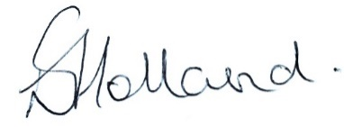
Liz Holland
Clerk to Alderbury Parish Council
27.2.26

