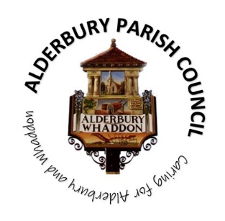**ALDERBURY PARISH COUNCIL**

Caring for Alderbury and Whaddon

**You are summoned to an ORDINARY MEETING of Alderbury Parish Council to be held 7.30 on Wednesday 8th October 2025**

**The Fountain Room at The Village Hall, Alderbury**

[**Supporting documents can be found on our website**](http://www.alderburyparishcouncil.gov.uk/Council_documents_39878.aspx)

**Councillors can find the supporting documents in the Cllrs and clerk Teams channel**

**NOTE this meeting will be preceded by a presentation from Biosouth starting at 7pm. Non-attendance at that does not require apologies.**

Alderbury Parish Council has signed the [Civility Pledge](https://www.nalc.gov.uk/campaigns/civility-and-respect.html#the-pledge)

Alderbury Parish Council has adopted a [forward plan](http://www.alderburyparishcouncil.gov.uk/_UserFiles/Files/Policy%20and%20Documents/Adopted%20forward%20plan%20Feb%202025.pdf) which will inform their decisions

**7.30**

15 minutes is set aside forthe public to ask questions.

Please restrict comments and/or questions to three minutes. After question time, the public will only be able to speak if invited by the Chair.

**AGENDA**

1. **ACCEPT** reports from **7.45**
   1. PC Kelvin Ramsey
   2. Wiltshire Cllr Gregory Cooper
2. **ACCEPT** Apologies for absencefor the reasons given
3. **RECEIVE** Declaration of Councillors’ Interests and Dispensations relating to matters on this agenda
4. **APPROVE** 
   1. [the minutes of the ordinary meeting held on 9th September 2025](http://www.alderburyparishcouncil.gov.uk/Meetings_Agendas__and__Minutes_34465.aspx)

1. **REVIEW** action logs
   1. Clerk’s list
   2. Cllr Sneddon’s list
2. **Planning 8pm**

**RESPOND** to:

1. [PL/2025/07530](https://development.wiltshire.gov.uk/pr/s/planning-application/a0iQ300000Gj78zIAB/pl202507530) - Existing overhead line changing from single to multi user, New Build, Alderbury Farm Cottage
2. **The playground, recreation ground, The Pavilion and youth activities** 
   1. **RECEIVE** a reporton youth activities
3. **Finance & IT 8.15** 
   1. **PROPOSAL** to make a donation to St John’s Ambulance
   2. **NOTE** the bank balances and bank reconciliation statement at 30.9.25
   3. **CONFIRM** transfer £30,000 to deposit account (receipt of precept)
   4. **NOTE** the accounts at 30.9.25 & forecast with first draft budget
   5. **NOTE** reserves including a year end forecast
   6. **CONFIRM** renewal of the insurance policy (year 3 of a 3 year agreement) £1,573.72 (budget £1,750)
   7. **PROPOSAL to APPROVE** the [schedule of payments and invoices received](http://www.alderburyparishcouncil.gov.uk/_UserFiles/Files/Accounts/payments%20schedule.pdf)
   8. IT policy
      1. **REVIEW** draft policy
      2. **CONSIDER** any implications

1. **Village maintenance issues 8.30** 
   1. **REPORT** new issuesfrom Cllr Hartford
   2. **REPORT** new issues to Cllr Hartford for inclusion on the parish steward’s list
   3. **UPDATE** on overhanging hedges review
   4. **APPROVE** cost and plans for new bins

1. **Allotments 8.45**
   1. **NOTE** report from the SRAA AGM 4.10.25
2. **Matters of community interest**
   1. Discuss possible costs of adding names to the war memorial
3. **Policies**
   1. **PROPOSAL to ADOPT** Wiltshire Pension Fund Discretions Policy
4. **The Fountain magazine –** agree key themes for the next article **9pm**
5. **Date of next meeting**
   1. Next meeting Thursday 13th November

*The agenda specifies the business that it is proposed to transact (Local Government Act 1972 Sch.12 para 10 (2)(b)) and the Council cannot lawfully decide any matter which is not specified in the agenda (Longfield Parish April Council v Wright (1918) 88 LJ Ch 119)*

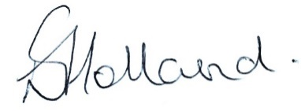

Liz Holland

Clerk to Alderbury Parish Council

2.10.25