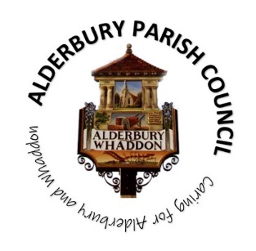**ALDERBURY PARISH COUNCIL**

Caring for Alderbury and Whaddon

**You are summoned to an ORDINARY MEETING of Alderbury Parish Council to be held 7.30 on Tuesday 9th September 2025**

**The Fountain Room at The Village Hall, Alderbury**

[**Supporting documents can be found on our website**](http://www.alderburyparishcouncil.gov.uk/Council_documents_39878.aspx)

**Councillors can find the supporting documents in the Cllrs and clerk Teams channel**

Alderbury Parish Council has signed the [Civility Pledge](https://www.nalc.gov.uk/campaigns/civility-and-respect.html#the-pledge)

Alderbury Parish Council has adopted a [forward plan](http://www.alderburyparishcouncil.gov.uk/_UserFiles/Files/Policy%20and%20Documents/Adopted%20forward%20plan%20Feb%202025.pdf) which will inform their decisions

**7.30**

15 minutes is set aside forthe public to ask questions.

Please restrict comments and/or questions to three minutes. After question time, the public will only be able to speak if invited by the Chair.

**AGENDA**

1. **ACCEPT** reports from **7.45**
   1. PC Kelvin Ramsey
   2. Wiltshire Cllr Gregory Cooper
2. **ACCEPT** Apologies for absencefor the reasons given
3. **RECEIVE** Declaration of Councillors’ Interests and Dispensations relating to matters on this agenda
4. **APPROVE** 
   1. the minutes of the ordinary meeting held on 11th August 2025

1. **REVIEW** action logs
   1. Clerk’s list
   2. Cllr Sneddon’s list
2. **Planning** 
   1. **RESPOND** to:
      1. [**PL/2025/06588** 47, Oakwood Grove, single storey extension](https://development.wiltshire.gov.uk/pr/s/planning-application/a0iQ300000Fvl9dIAB/pl202506588)
3. **The playground, recreation ground, The Pavilion and youth activities 8pm**
   1. **RECEIVE** a reporton youth activities
   2. **PROPOSAL to AGREE** a protocol for minor repairs (playground and more widely)
   3. **PROPOSAL to APPROVE** minor repair costs £44 to Cllr Mike Sneddon
   4. **PROPOSAL** to replace the pedestrian gate at the recreation ground – agree spend up to £1,000
4. **Finance & IT** 
   1. **NOTE** the final external auditor report for 2024/25 – no issues raised
   2. **NOTE** the bank balances and bank reconciliation statement at 31.8.25
   3. **PROPOSAL** to transfer £20,000 from the deposit account to the current account
   4. **PROPOSAL to APPROVE** the [schedule of payments and invoices received](http://www.alderburyparishcouncil.gov.uk/_UserFiles/Files/Accounts/payments%20schedule.pdf)
   5. **CONFIRM** up to £3,000 to be spent from earmarked reserves on garden machinery – this payment will probably be made between meetings

1. **Village maintenance issues 8.15** 
   1. **REPORT** new issuesfrom Cllr Hartford
   2. **REPORT** new issues to Cllr Hartford for inclusion on the parish steward’s list
   3. **UPDATE** on overhanging hedges review
   4. **DISCUSS** tree watering at Pembroke Gardens
   5. **APPROVE** cost and plans for new bins
2. **Matters of community interest** 
   1. **REPORT** from the Area Board meeting
   2. **CONSIDER** a letter from the CPRE
3. **Highways & footpaths** 
   1. **NOTE** updates on LHFIG requests
4. **Allotments 8.30**
   1. **REPORT** from recent meetings of the working group and the SRAA committee
   2. **DISCUSS** issues raised
   3. **PROPOSALS:**
      1. **AGREE** to support the SRAA making a bid to have the site listed as an asset of community value
      2. **AGREE** to extend eligibility to Clarendon residents
5. **The Fountain magazine –** agree key themes for the next article **8.45**
6. **Dates for meetings**
   1. Next meeting Wednesday 8th October
   2. **PROPOSAL to AGREE** meeting dates for 2026 – rotation through days of the week in the second full week of the month (July has been varied):

TUESDAY 13th January (subject to having set the precept in December)

WEDNESDAY 11th February

THURSDAY 12th March

MONDAY 13th April

TUESDAY 12th May

WEDNESDAY 10th June

THURSDAY 9th July

MONDAY 10th August

TUESDAY 15th September

WEDNESDAY 14th October

THURSDAY 12th November

MONDAY 14th December

*The agenda specifies the business that it is proposed to transact (Local Government Act 1972 Sch.12 para 10 (2)(b)) and the Council cannot lawfully decide any matter which is not specified in the agenda (Longfield Parish April Council v Wright (1918) 88 LJ Ch 119)*

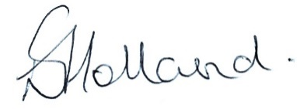 Liz Holland

Clerk to Alderbury Parish Council

3.9.2025