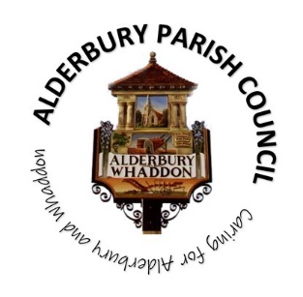**ALDERBURY PARISH COUNCIL**

Caring for Alderbury and Whaddon

**You are summoned to an ORDINARY MEETING of Alderbury Parish Council to be held 7.30 on Wednesday 11th June 2025**

**The Fountain Room at The Village Hall, Alderbury**

[**Supporting documents can be found on our website**](http://www.alderburyparishcouncil.gov.uk/Council_documents_39878.aspx)

**Councillors can find the supporting documents in the Cllrs and clerk Teams channel**

Alderbury Parish Council has signed the [Civility Pledge](https://www.nalc.gov.uk/campaigns/civility-and-respect.html#the-pledge)

Alderbury Parish Council has adopted a [forward plan](http://www.alderburyparishcouncil.gov.uk/_UserFiles/Files/Policy%20and%20Documents/Adopted%20forward%20plan%20Feb%202025.pdf) which will inform their decisions

**7.30**

15 minutes is set aside forthe public to ask questions.

Please restrict comments and/or questions to three minutes. After question time, the public will only be able to speak if invited by the Chair.

**AGENDA**

1. **ACCEPT** reports from **7.45**
   1. PC Kelvin Ramsey
   2. Wiltshire Cllr Gregory Cooper
   3. Jim Hubbard – Green Dragon survey
2. **ACCEPT** Apologies for absencefor the reasons given
3. **RECEIVE** Declaration of Councillors’ Interests and Dispensations relating to matters on this agenda
4. **APPROVE** 
   1. the minutes of the annual meeting held on May 13th 2025 **8pm**
   2. the minutes of the annual parish meeting March 27th 2025

1. **REVIEW** the action log
2. **UPDATE on** co-option for the vacancy on the council
3. **Planning** 
   1. **RESPOND** to:
      1. **PL/2025/04427** The Chapel, Southampton Road – change of use
      2. **PL/2025/03217** Kiln Close – excavation of the embankment and 4 self-build properties
   2. **NOTE** email from neighbour to the Wagtails development
4. **Finance & IT 8.15**
   1. **CONSIDER** a grant application from Friends of Alderbury School (Note the requested amount is included at d below)
   2. **NOTE** the bank balances and bank reconciliation statement at 31.5.25
   3. **NOTE** the accounts to 31.5.25
   4. **NOTE** reserves forecast at 31.5.25
   5. **APPROVE** the [schedule of payments and invoices received](http://www.alderburyparishcouncil.gov.uk/_UserFiles/Files/Accounts/payments%20schedule.pdf)
   6. **PROPOSAL** to instruct the IT working group to make a recommendation on a website update
   7. **PROPOSAL** to accept a quote for electricity supply renewal (current contracts end September)

1. **Village maintenance issues 8.30** 
   1. **REPORT** new issuesfrom Cllr Hartford
   2. **REPORT** new issues to Cllr Hartford for inclusion on the parish steward’s list
   3. **Flooding**
      1. **CONSIDER** a letter from a resident
   4. **PROPOSAL** to set up a working group to draft a new grounds maintenance contract & litter collection to begin 2026
   5. **PROPOSAL** to accept a quote for stile and fence repairs at the recreation ground
2. **Matters of community interest** 
   1. **UPDATE on** the Post Office’s request for amended parking restrictions outside the shop
   2. **UPDATE** on parking at Windwhistle Way and the Avon Drive area
   3. **UPDATE** on meeting with The Longford Estate about safety at the Junction Road/ALDE20 junction
   4. **CONSIDER** Community Transport (S Wiltshire) offer to come to make a presentation
3. **Highways 8.45**
   1. **NOTE** LHFIG turned down a direction sign to the new guide hut
   2. **SIDs**
      1. **UPDATE** on positioning third post
      2. **DISCUSS** downloading speed data
4. **The playground, recreation ground, The Pavilion and youth activities** 
   1. **UPDATE** from the Hub WG on their meeting 20.5.25
5. **Reports and consultations** 
   1. **REPORT** from the footpaths working group
   2. **REPORT** from the Allotment working group, including update from Formula Land on the licence extension
   3. **REPORT** from meeting with Biosouth20th May
6. **The Fountain magazine –** to agree the key themes for the next article **9pm**
7. **Date of next meeting –** Thursday July 10th

*The Agenda specifies the business that it is proposed to transact (Local Government Act 1972 Sch.12 para 10 (2)(b)) and the Council cannot lawfully decide any matter which is not specified in the Agenda (Longfield Parish April Council v Wright (1918) 88 LJ Ch 119)*

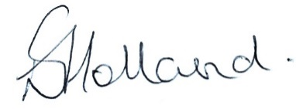 Liz Holland

Clerk to Alderbury Parish Council

5.6.2025