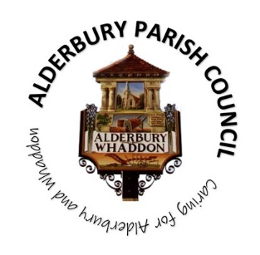**ALDERBURY PARISH COUNCIL**

Caring for Alderbury and Whaddon

**You are summoned to an ORDINARY MEETING of Alderbury Parish Council to be held 7.30 on Monday 7th April 2025**

**The Fountain Room at The Village Hall, Alderbury**

Alderbury Parish Council has signed the [Civility Pledge](https://www.nalc.gov.uk/campaigns/civility-and-respect.html#the-pledge)

Alderbury Parish Council has adopted a [forward plan](http://www.alderburyparishcouncil.gov.uk/_UserFiles/Files/Policy%20and%20Documents/Adopted%20forward%20plan%20Feb%202025.pdf) which will inform their decisions

**7.30**

15 minutes is set aside forthe public to ask questions.

Please restrict comments and/or questions to three minutes. After question time, the public will only be able to speak if invited by the Chair.

**AGENDA**

1. **ACCEPT reports from** 
   1. PC Kelvin Ramsey
   2. Wiltshire Cllr Richard Britton
2. **ACCEPT** Apologies for absencefor the reasons given
3. **RECEIVE** Declaration of Councillors’ Interests and Dispensations relating to matters on this agenda
4. **APPROVE** the minutes of the meeting held on March 13th 2025
5. **REVIEW** the action log
   1. **REPORT** on any migration to Office 365 issues

1. **Planning 7.45**
   1. **RESPOND** to:
      1. [PL/2025/03038 Old Rectory House tree work](https://development.wiltshire.gov.uk/pr/s/planning-application/a0iQ300000DUY1Z/pl202503038) in a conservation area
   2. **NOTE** [PL/2025/02984](https://development.wiltshire.gov.uk/pr/s/planning-application/a0iQ300000DTex4IAD/pl202502984) work on trees with TPOs on the Avon Drive estate (per tree report – our submission)
   3. **Land East of Wagtails**
      1. **UPDATE** on Heritage Homes consultation March 15th including [a comment from a resident](http://www.alderburyparishcouncil.gov.uk/_UserFiles/Files/Council%20documents/2025-26/correspondence.pdf)
      2. **CONSIDER** a [report on affordable housing](http://www.alderburyparishcouncil.gov.uk/_UserFiles/Files/Council%20documents/2025-26/Affordable%20homes.docx)
      3. **AGREE** next steps

1. **Matters of community interest 8.00**
   1. **CONSIDER** communications from residents
      1. **NOTE** [reply from Historical railways engineer, Alistair Dore on the bridleway closure](http://www.alderburyparishcouncil.gov.uk/_UserFiles/Files/Council%20documents/2025-26/correspondence.pdf)
   2. **REPORT** on Annual Parish Meeting 27.3.25
   3. **NOTE TPO/2024/00032** Land adjacent to the Three Crown has been granted
2. **Highways**
   1. **UPDATE** on flood recording system
   2. **REPORT** any gullies for clearance

1. **Village maintenance issues** 
   1. **REPORT** new issuesfrom Cllr Hartford
   2. **REPORT** new issues to Cllr Hartford for inclusion on the parish steward’s list
2. **Finance & IT 8.15** 
   1. **NOTE** the [bank balances at 31.3.25](http://www.alderburyparishcouncil.gov.uk/_UserFiles/Files/Accounts/2024-25/Mar%2031st%202025.pdf) and sign off the reconciliation for year end
   2. **NOTE** the [accounts at 31.3.25](http://www.alderburyparishcouncil.gov.uk/_UserFiles/Files/Accounts/2024-25/at%20year%20end%2031.3.25.pdf)
   3. **APPROVE** the [schedule of payments and invoices received](http://www.alderburyparishcouncil.gov.uk/_UserFiles/Files/Accounts/2025-26/payments%20Apr%202025.pdf)
   4. **UPDATE** on the pre-school grant application
3. **The playground, recreation ground, The Pavilion and youth activities** 
   1. **CONSIDER** [recommendations from the inspections summary](http://www.alderburyparishcouncil.gov.uk/_UserFiles/Files/Council%20documents/2025-26/inspections%20summary.pdf)
   2. **UPDATE** from the youth forum
   3. **UPDATE** from the Hub WG on latest equipment installation and orders
4. **Reports and consultations 8.30** 
   1. Local Nature Recovery Strategy
5. **The Fountain magazine –** to agree the key themes for the next article
6. **Date of next meeting –** TUESDAY MAY 13th **–** new council and annual meeting of the council

*The Agenda specifies the business that it is proposed to transact (Local Government Act 1972 Sch.12 para 10 (2)(b)) and the Council cannot lawfully decide any matter which is not specified in the Agenda (Longfield Parish April Council v Wright (1918) 88 LJ Ch 119)*

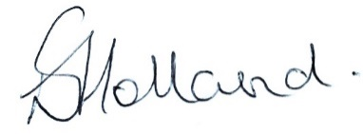

Liz Holland

Clerk to Alderbury Parish Council

1.4.25