**ALDERBURY PC – HUB WG**

**Meeting: 20.5.25**

* Next project will be path from the car park to the Pavilion
  + **BJ to scope**
  + **Clerk to get quotes** from Russ, Vitaplay, Abelia Landscapes
* Possibly plant silver birch and/or hedge in the damp area near the bowls club fence
* Possibly a bench in this area too
* Consider bollards in the entrance at that end to stop vehicle access
* **Clerk to ask** Vitaplay to fix the zip wire sheath (at seat)
* **Clerk to ask** MH to re-tape the basket swing
* **Clerk to ask** about repairs to surfacing
* Consider signage1 needed including restricting dog access **ACTION: CR to investigate byelaws** (his email 22/5 & my comments 29/5)

Update 29.5

WC meeting attended by clerk

The Dog Exclusion (WC) Order 2012 lapsed and was replaced by blanket PSPOs2 in 2017 but these too have lapsed.

There is now no power to issue on-the-spot fines

The dog warden team intend to apply again for PSPOs and will launch a consultation with PCs beforehand. (No timescale given). They stressed there MUST be a good reason to ban dogs. I do wonder if without fenced off play areas (easy to ban dogs) whether the whole field would qualify. (Apparently the Kennel Club will always oppose blanket orders).

Currently any signage is ‘advisory’. Only power is to enforce the control of dogs – usually used for dogs running about in a threatening or dangerous way, though.

At the end of the day, enforcement will always be really difficult.

Officer was very open to a suggestion that WC as a whole have a publicity campaign about the issue. Their crack down on fly tipping has been judged very successful – model on that?

2 You may remember the use of catapults one you supported last year

1 As I walked past a couple of play areas near me I took these photos which we might use as a model:

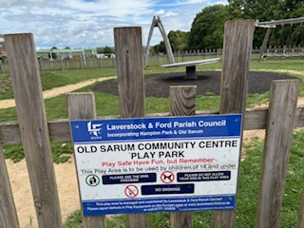

This one is at a fenced play area & includes a no dogs request

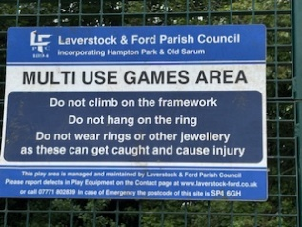

This one is at their basketball hoop and is open on the field – so no mention of dogs.

LH 29.5.25