Alderbury Parish Council
March 2026

Agenda item 179.25c
This matter was brought to your attention by another resident last May & JF said then it is not a PC responsibility as the road is private. Since then Cllr Dent has also spoken about it and here is another resident concerned by it. Please let me know if your response remains the same – the correspondent needs to take this up with the owner (Longford).

- Original letter put through Elaine’s door
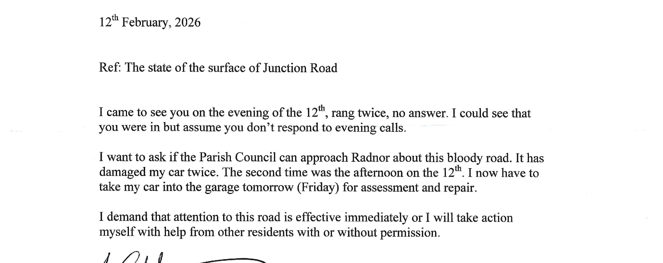

- My reply

Councillor Hartford passed your recent letter to me. Please note our correspondence address below should you wish to write again. Email is usually quicker if you use it and again, the details are below.

I will include consideration of your letter on the March agenda. You are welcome to attend the meeting to put your case personally and to listen to councillors’ discussion. Public time starts at 7.30. We meet in The Fountain Room at the village hall. The next meeting is Thursday March 5th.

- Correspondent replied:

Dear Mrs/Miss Holland
Thank you for your letter of the 13th instant.

I do appreciate that my concern regarding the state of Junction Road is going to be given consideration in the March agenda. However, sadly I cannot attend the meeting because as from this Sunday 20th I am out of the country until 23rd March.

FYI
This is not actually on the agenda

Dear Liz,

As discussed, on behalf of the PC I gave our approval for the Social Club to run an Easter Egg Hunt on the Recreation Ground on Saturday 28th March.

Matt Gilvarry is aware of the Parish Council's and the Social Club's H&S, Safeguarding and other formal responsibilites and so asked for approval at the recent VH Ctte meeting.

Regards,

Mike H

