## ALDERBURY PARISH COUNCIL

## BINS

## Update for 8/10/25 meeting

We are in a position to order 2 new bins 1 & 2 below.

**PROPOSAL** Spend up to £500 for the bins then allow £100 installation and £30 ea per month collection costs

3 & 4 need permission from LE, and JJ’s initial response was ‘no’.

5 will the arguments JJ uses about why private landowners are not keen to see bins on their land mean a ‘no’ here? I can ask, but I’m not hopeful.

6 whilst strictly speaking this is again private land, there feels a better chance of a positive reply given it does look like an ordinary verge.

|  |  |  |  |
| --- | --- | --- | --- |
| **Where** | **What is needed** | **Approx cost** | **Notes/MS map** |
| Firs Road – outside woods where path comes down at S’ton Rd end | New bin | £200 - £250 (see spec below) + installation & ongoing collection costs | Put on bank – check with LE  AGREED with JJ 26/9 can be on bank at the pavement level 1 |
| Avon Drive - outside woods at gate | New bin | As above | CONFIRMED APC land 2 |
| Rectory Road – where road becomes path | New bin | On hold | Check with LE  JJ said ‘no’ but will consult with LE 26/9  3 |
| Rectory Road – gate in orchid field | New bin | On hold | Check with LE  As 3  4 |
| Matron’s College Farm at the circular walk | New bin | On hold | This is where KD lives I think, so will check with her  On private land – asked by email if we should continue – no reply by 29/9 5 |
| AWGS at end of ALDE20 | New bin | On hold | I’ve emailed RS to see if WC own it  It is Diocese land. Per JJ 26/9 ask school for permission – email 30/9 6 |
| On recreation ground  Nr skate park  Nr swings | Re- cement current bin  Bin is damaged but still functional | Within clerk’s delegated authority R & M budget  n/a | MS will do    NFA |
|  |  |  |  |

<https://britishrecycledplastic.co.uk/product/wharfe-120-litre-litter-bin/>

approx. £240ea. 4.6 Trustpilot rating 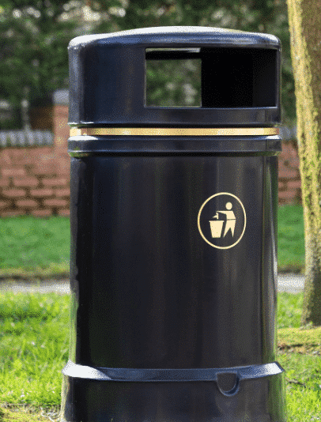

Similar look to ones we have but not identical

100% recycled plastic

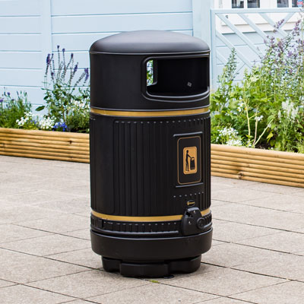<https://uk.glasdon.com/topsy-royale-tm-litter-bin?mx=1&gad_source=1&gad_campaignid=16282475168&gbraid=0AAAAADNP1nNuBR8dPVoEexWdPMsBV29Pe&gclid=Cj0KCQjwuKnGBhD5ARIsAD19RsbCsFKdPCuSZJgTK-RKKVdMMAZ_lLvjahS1SguFN7vs8f6JUZ_JUIEaApkEEALw_wcB>

Very popular supplier to PCs – market leader

What we have currently

15% recycled plastic

Approx. £195ea.