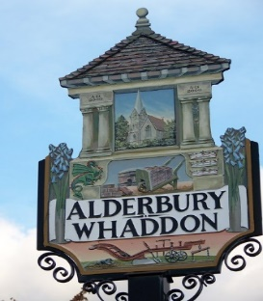
ALDERBURY & WHADDON
ANNUAL PARISH MEETING
WEDNESDAY MAY 22nd 2024 7pm
in ALDERBURY VILLAGE HALL

Local organisations have been invited to attend and their tables will be open from 7pm with the meeting starting at 7.30

AGENDA – to start at 7.30
- WELCOME from Alderbury & Whaddon Parish Council Chair
- WC councillor Richard Britton to say a few words and take questions
- PC Harry Murphy to say a few words & take questions
- PRESENTATION and Q&A Great Green Bedwyn
- REPORT from the Chair of Alderbury Parish Council
- REPORT from Alderbury Village Hall
- PRESENTATION and Q&A from the parish council’s working group for development of the Recreation Ground
- Any other questions

The accounts for 31.3.24 will be available

