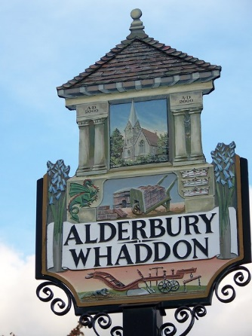
ALDERBURY & WHADDON
ANNUAL PARISH MEETING
WEDNESDAY MAY 22nd 2024 7.30 in ALDERBURY VILLAGE HALL

AGENDA
- WELCOME from Alderbury & Whaddon Parish Council Chair + presentation to someone in Alderbury who has made a significant contribution to the village | 3 minutes
- WC councillor Richard Britton to say a few words and take questions | 7 minutes
- PC Harry Murphy to say a few words & take questions | 7 minutes
- PRESENTATION and Q&A Great Green Bedwyn | 25 minutes
- REPORT from Alderbury Village Hall | 5 minutes
- REPORT from the Chair of Alderbury Parish Council | 10 minutes
- PRESENTATION and Q&A from the parish council’s working group for development of the Recreation Ground | 20 minutes
- Any other questions | 13 minutes
TOTAL 90 minutes

A simplified version of the accounts will be attached

