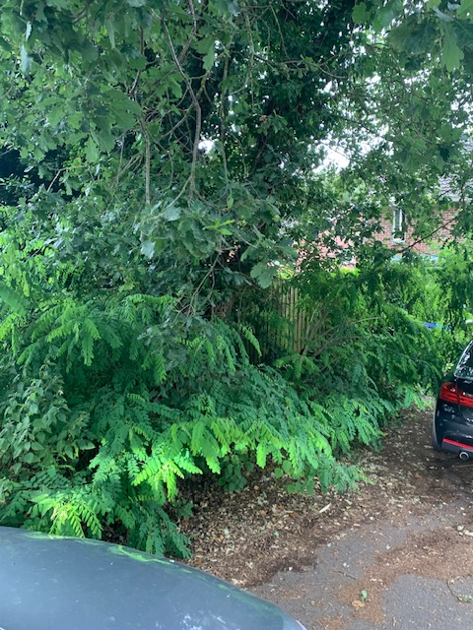

Hi Liz & Elaine,

I've not seen a response to the below email.

In the interests of protecting the property I occupy at present I would like to arrange for this tree to be removed. Would the parish council have any objections if I was to proceed with this on my own?

As you're responsible for the land (as clarified before and my neighbour Shirely Webb can confirm too) I would like to gain permission from yourselves to have this tree removed.

Please confirm if you grant permission for us to proceed with having a tree surgeon in to look at removing this tree.

Many thanks,

Duncan Jones
On 25/07/2023 09:14 BST Duncan Jones <duncan.jones@hippylife.co.uk> wrote:

Hi Liz,

Thank you for responding.

I’m surprised that the parish council are still claiming they are not responsible for this land. My next door neighbour has been asking about this for a long time and I believe it was someone from the land registry (I might be wrong on who it was) that confirmed to my neighbour and to Elaine that the parish council is responsible for this land.

As mentioned in my emails I’m concerned this tree that has been neglected could cause damage to the property I occupy and if this does happen and it is proved the parish council are responsible for this land then this would be negligence on behalf of the council.

I look forward to hearing back about your planned actions for this tree and the land around it.

Many thanks,

Duncan Jones

