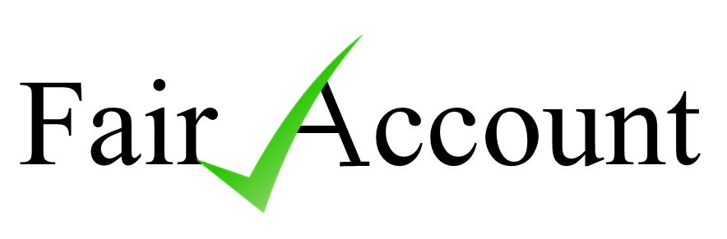 Mobile: 07815 435 380
1 Roker Way
Fair Oak
Eastleigh
HANTS
SO50 7LD
Website: www.townandparishaudit.co.uk
31 July, 2026 E-mail: paulreynolds48@hotmail.com
Liz Holland
Parish Clerk/RFO
Alderbury Parish Council
Alderbury
WILTS
SP2 2NY
Dear Liz,
Alderbury Parish Council Internal Audit 2023/24
Further to your recent email & our telephone conversation, I am writing to confirm that I am pleased to quote for the 2023/24, Internal Audit for your Council. I can confirm that I am a fully qualified FMAAT, holding full PI cover, and am AAT Licensed to engage in Public Practice.
I would be willing to undertake the “lighter touch” Internal Audit of the Council for 2023/24 at an annual fee of £600 (incl. travel costs & a current inflation uplift). This would be based on the standard Internal Audit, with AGAR review, performed by a combination of remote electronic data transfer audits & one onsite visit. This lowers our carbon footprint & costs by reducing overnight stays & travel expenses. There will be no extra charges, unless any agreed, other project work was requested.
Our normal, medium/large audits are performed by 1 or 2 Interim, & a Year-end AGAR audit. This provides ongoing assurance to Councillors & Clerks during the year, and this facility is utilised by most of our present, Council audits. The annual fee applies to the stated frequency, thus no extra charge for this interim audit service.

Relevant CV information for your perusal as follows:
- Fellow Member Association of Accounting Technicians.
- Licensed and regulated by the AAT for Public Practice. (Licence no.1530)
- 35 years Local Govt. internal audit experience, with large County, City and Unitary Councils, latterly as Group Auditor.
- 22 years’ experience on Parish and Town Council internal audits from the outset of the ‘lighter touch’ regulations, and included on the approved listings for Hampshire, Wiltshire, Dorset, IOW, Somerset, Berkshire, Sussex, Surrey and SLCC.
- Currently the Internal Auditors for 62 Parish and Town Councils in the South & Southwest of England. Should you require any comments on our audit standards, please contact the Town Clerks or RFO’s at Bridport & West Moors (both Dorset), Frome (Somerset), Woodley (Berks) and Blackwater & Hawley (Hants), or Clerks for larger Parishes at Prestbury (Glos), Corfe Castle (Dorset), Downton (Wilts), Lyndhurst, Brockenhurst & West End, (all Hants), Compton (West Sussex) and Wokingham Without (Berks).
- Also, I conduct Audits & Independent Examinations on a range of Youth Clubs & Managed Village Halls linked to Local Councils.
- Lecturer for SLCC & AAT on Audit aspects, for last 22 years.
- Full Professional Indemnity insurance cover provided.
I would be happy to discuss the proposal further, if required.
I look forward to hearing from you shortly.
Yours sincerely,

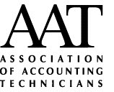
PAUL REYNOLDS, FMAAT

