**House Martins**

House Martins are summer residents, arriving in the UK from Africa between March and May, returning to the same nest locations year after year. They usually leave in September. Numbers in the UK have declined 57% between 1969 and 2018 and they were reclassified as red listed in the “birds of conservation concern” report in 2021.

**SASH** - Our Objective is to increase the numbers of House Martins in and introduce swifts to Alderbury.

Both are red listed birds. House Martins already nest in Alderbury, swifts do not but are in the surrounding areas including Salisbury, Downton, Laverstock and Charlton-All- Saints. As their feeding range is 10 miles there is every chance that we can attract them to nest here as well. However this year our strategy is to focus on House Martins as we already have nesting birds here. 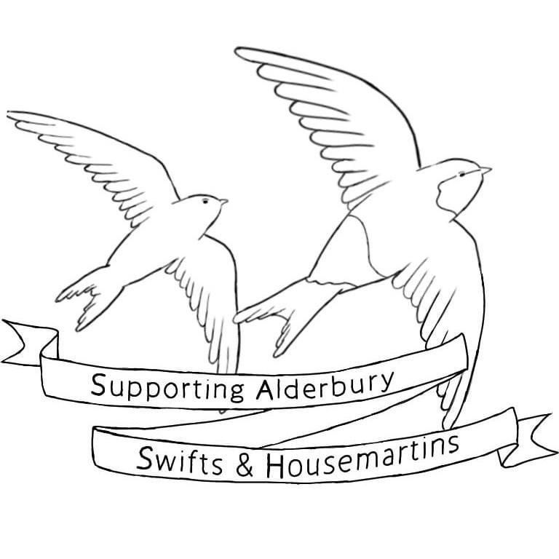

**Our plan is to:**

**Annually survey the birds.** We will do this primarily online and gather information on how many nesting sites we have in Alderbury and where they are. By doing this annually we hope to see if their numbers are increasing or decreasing.

**Encourage nesting sites.** Sometimes House Martin nests may fall due to materials used. Long periods of dry weather can make it hard for House Martins to find mud to build and repair their nests. We can advise residents on artificial nest cups (ANCs) and swift nest boxes/swift bricks and help with installation/provide ANC where cost is a problem for residents.

**Raise awareness.** We understand that many people may not like House Martins nesting on their house/building. We hope to spread our love of these beautiful birds and provide support for those living and wanting to live alongside them, such as advice on fitting droppings boards, explaining how at risk they have become.

**Some of our activities to date:**

* Expression of interest made at 18/5/23 Parish Council meeting regarding a grant application
* Articles in the Fountain and Alderbury Residents Facebook page to raise awareness & establish whether swifts nest in the village
* Facilitating Dan from Salisbury and Wilton Swift Group as a speaker at the Parish Meeting on 18/5/23
* Alderbury Residents Face book page survey of House Martin nests & incidence of falling nests. Launched 17/8/23 (based on the House Martin Conservation group survey form)
* Follow up on the ground survey of House Martin nests 20/8/23
* Review of Swift Mapper (a nationwide record of swift nesting locations)
* Speaking to residents eg at The Boundary Coffee shop, Parish Meeting and Picnic at the Park to establish whether swifts nest in the village and where House Martins are nesting
* Collaborating with the Parish Council’s green group, Alderbury Clothing Exchange, Salisbury and Wilton Swift Group, Bentley Wood Wildlife Buffer Zone, Alderbury Cubs

**Results**

HM’s nest at:

* Orchards Estate (notably Tozer way)
* Behind the 3 Crowns
* Castle Lane
* The Sandringhams
* Silverwood
* Oakwood Grove
* High Street & Behind the Green Dragon
* Near to Kennel Farm/Alderbury House Lodge (could not locate actual nests due to access constraints)
* Witherington Farm

75% of the respondents to our FB survey who had had nesting House Martins had experienced falling nests, and in several cases the birds had not returned. Several requested ANC.

We noted that, unlike other areas, the birds in Alderbury tended to just have one or two nests rather than the more usual larger colonies.

Several streets had taken deterrent actions such as knocking down the nests, fitting spikes in apexes. Other areas had allowed birds to nest above doors and windows and several people spoken to were extremely fond of their annual visitors and proud that they were able to do their bit for conserving these birds.

**Indication of Expected spend of grant money:** monies may need to be vired between headers

**Encouraging nesting sites:**

* **Public liability Insurance** to cover ladder volunteers & damage to property etc for 12 months £205 (Ansvar Insurance)
* **ANC/Droppings boards** – £460 : We estimate £360 for ANC based on locations that are within 700 m of an existing next. Estimate of 14/15 at £22 each – with donations sought to cover cost to ensure we can continue to offer ANC installation widely. Inc Providing swift box @ £30 free to the school as well as ANC @ £22 or £40. Dropping Boards and fixings £100 estimate (need to contact Men’s shed Salisbury for firm price)

**Raising Awareness**:

* **Table top display board**, can be shared with other groups eg PC green group £90
* **Printing/leaflets/posters** for raising awareness/recruiting more bird surveyors £15