1 Roker Way
Fair Oak
Eastleigh
HANTS
SO50 7LD
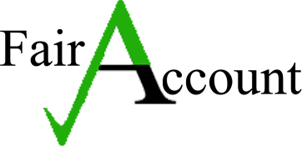 Tel (07815) 435 380
3 November, 2023 E-mail: paulreynolds48@hotmail.com

Liz Holland
Clerk to Alderbury Parish Council
PO Box 2366
Alderbury
SALISBURY
SP2 2NY
Dear Liz
Alderbury Parish Council 2023/24 (4/23 to 9/23) Audit
I have now completed the first interim Internal Audit for the Council as at 30/9/23 & am pleased to report that the overall internal control procedures are adequate to meet the needs of the AGAR Practitioner’s Guide 2023 and the Accounts & Audit Regulations 2015 (as amended).
A series of test checks on the Council’s financial records, vouchers, documents, minutes, policies, insurance & assets register were done to ascertain efficiency & effectiveness of the Council’s systems.
Any attached Audit recommendations will only enhance the current processes and procedures.
This report should be noted & taken to the next meeting of the Council for discussion & formal minuting.
I would like to thank you for enabling the audit to be performed remotely, due to current adverse weather conditions. I look forward to hearing your comments in due course.
Yours sincerely
PAUL REYNOLDS, FMAAT 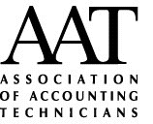

Audit Comments & Recommendations

- Precept has been fully received for £56,940 as at 30/9/23.
- The overall Bank holdings at 30/9/23 agreed as £125,456.53.
- VAT refund at £2,761.59 was received on 5/6/23.
- CIL money was received at £24,290.19 on 30/6/23.
- Bank interest earned has increased to £334.54 upto 30/9/23, as savings rates have risen.
- The first PWLB loan repayment for 2023/24, made 21/6/23 totalling £2,569.93.
- Recommend that the Asset register needs serial nos. added for all IT equipment & any other electrical items, as well as any external items (eg. Stihl items). This will provide the required data for any future BHIB Insurance claims.
- Recommend that all relevant Risk assessments are completed & minuted before 31/3/24, to meet External Audit requirements.
- Current insurance policy with BHIB covers all the standard Local Council aspects. Recommend that it may also be prudent to consider taking out Cyber cover with BHIB, as there is a growing trend of attacks on local authorities as per an NAO cyber report.
- All minutes are being regularly signed at next meeting, thus ensuring any decisions taken become lawful.
- All necessary AGAR documentation, Notice of Public Rights & Conclusion of Audit papers were entered onto website.

